Database and Management System Lab

Lab Experiment – 12

Name: Akshat Srivastava

Batch 2

Roll No: R21442230052

Sap_ID: 500123177

Title: To understand the concepts of Sequence.

Objective: Students will be able to implement the concept of sequence.

1. Create a sequence by name EMPID_SEQ starting with value 100 with an interval of 1.



1. Write a SQL command for finding the current and the next status of EMPID_SEQ.

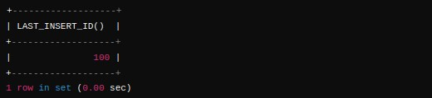

1. Change the Cache value of the sequence EMPID_SEQ to 20 and maxvalue to 1000.



1. Insert values in the EMPLOYEES table using sequences for the Employee_id column.



1. Drop sequence EMPID_SEQ.



Database and Management System Lab

Lab Experiment – 13

Name: Garvit Rana

Batch 1

Roll No: R21442230026

Sap_ID: 500119405

Title: To understand the concepts of PL/SQL programming.

Objective: Students will be able to implement the basic concepts of Pl/SQL.

1. Write a PL/SQL code to accept the value of A, B & C and display which is greater.

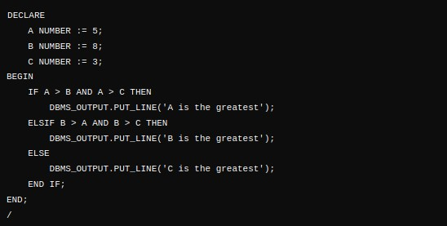

1. Using PL/SQL Statements create a simple loop that displays the message “Welcome to PL/SQL Programming” 20 times.

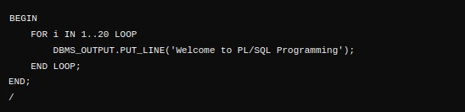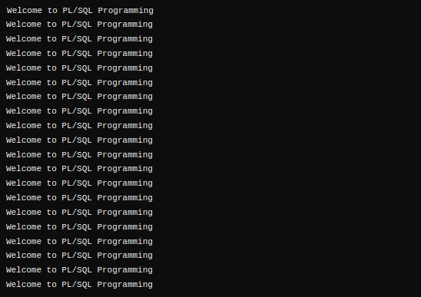

1. PL/SQL Code to Find the Factorial of a Number

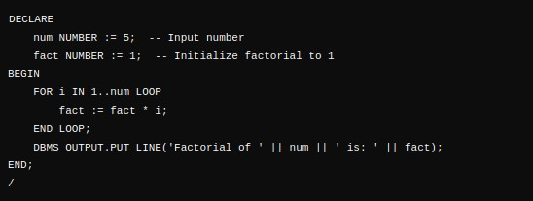

1. PL/SQL Program to Generate Fibonacci Series

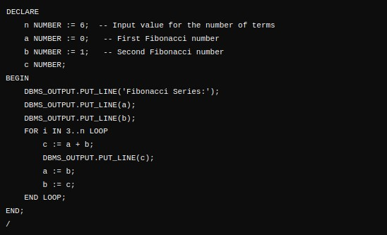

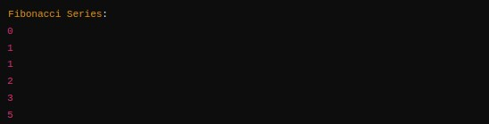

1. PL/SQL Code to Find the Sum of First N Numbers

